

American International University- Bangladesh

CSC 3222: Web Technologies

CO1.1 and CO2.1 Evaluation

Project Report

Fall 19-20

Project Title: News Portal Management System

Section: F

|  |  |
| --- | --- |
| Student Name | Student Id |
| AHMED, MD. FOYAZ | 17-35214-2 |
| RANA MD. RATAN | 18-37631-1 |
| SARKER BISHAL | 17-35764-3 |
|  |  |

Introduction:

This is the modern era. People are interested to see news in online rather than offline news. As the whole world are depending on internet, they are keenly thirst for reading newspaper by using internet. To maintain a news portal site, it’s hard to maintain all of the official site. We are doing this project because of being those people are interested for managing a news portal site, they can easily manage the whole sites as well as services any type of news.

Background Study

To be truth we had no idea about this type of project then me and my group member search in the google for some news base website where we found some concept about of this type of project. The references of those sites are given below

Reference:

<https://samakal.com/>

<https://www.dailyinqilab.com/>

<https://bangla.bdnews24.com/>

Requirement Analysis:

1. User Category:

There are 4-types of Users here. They are:

* Admin
* News Editor
* Journalist
* Reader

1. Feature List:

In this project the “Admin” has the following features:

* Can log in
* Can registration
* Can control office employee[Journalist, News Editor] (insert, update, delete)
* Can control reader (insert, update, delete)
* View on profile
* Can edit own profile
* Can change password
* Can change profile picture
* Can see particular office employee information by searching Id
* Can see whole office employees Information

In this project the “News Editor” has the following features:

* Can log in
* Can registration
* Can see the whole office employee information but does not edit it.
* Can insert, update, delete news.
* View own profile
* Can edit own profile
* Can change profile picture

In this project the “Journalist” has the following features:

* Can log in
* Can registration
* Can see the whole office employee information but does not edit it.
* Can collect news
* Can edit reader information (insert, update, delete)
* View own profile
* Can edit own profile
* Can change profile picture

In this project the “Reader” has the following features:

* Can give review
* Can read news

Design:

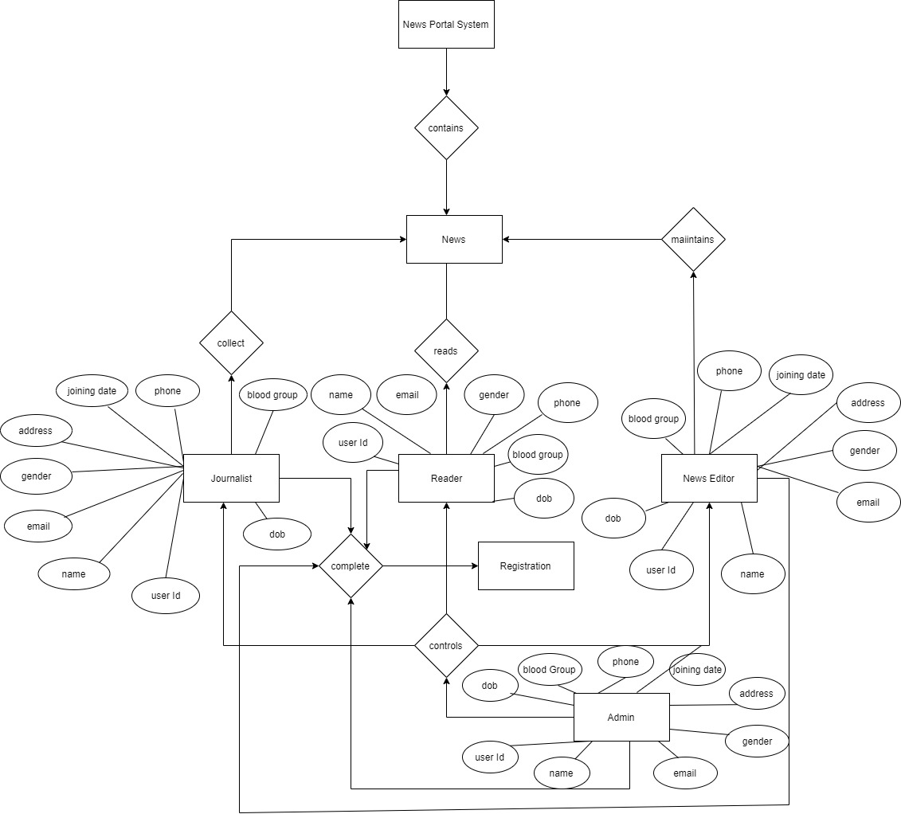

Tools Used:

To develop this project, we have used the following:

• Notepad++

• Xampp

System Images against the Specification:

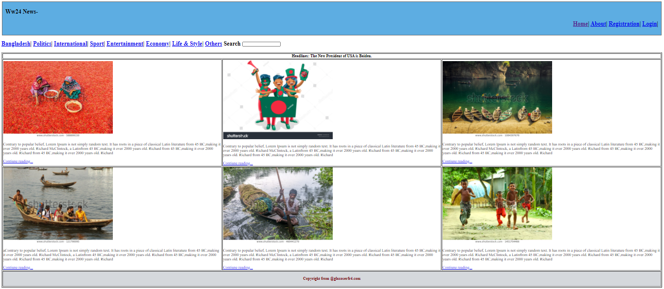

This is our home page where people can see the headline, recent news. User can login by clicking login link and can easily register after touching the registration link those are in the header. Navigation bar contains different types of news as well as shows the recent news by column wise.

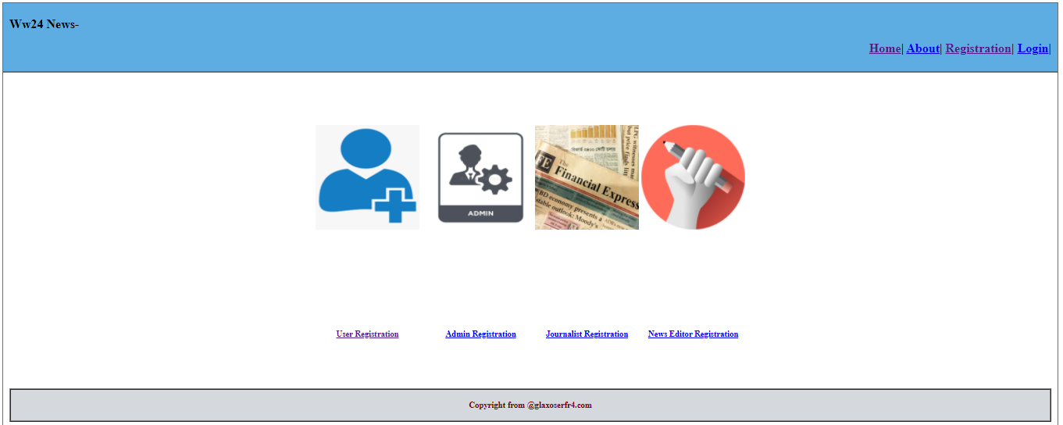

This is the registration page User can registration their category wise.

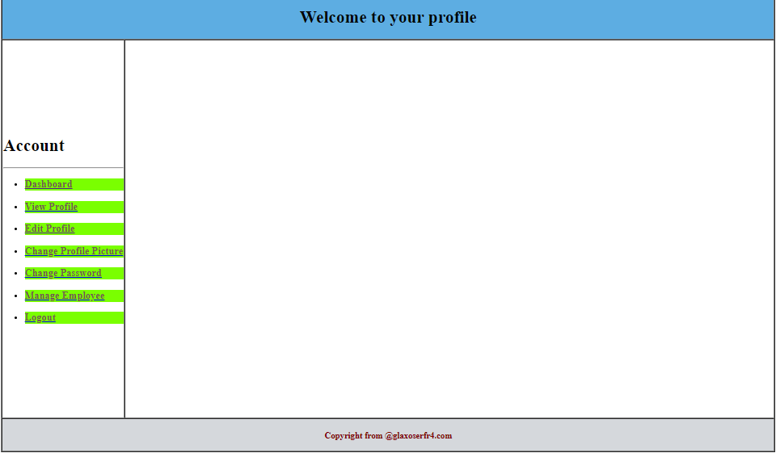

After login User enter this page, we just show here a sample, suppose admin is logged in and Enter this page. Where he can manage everything. Now he clicks on edit profile-

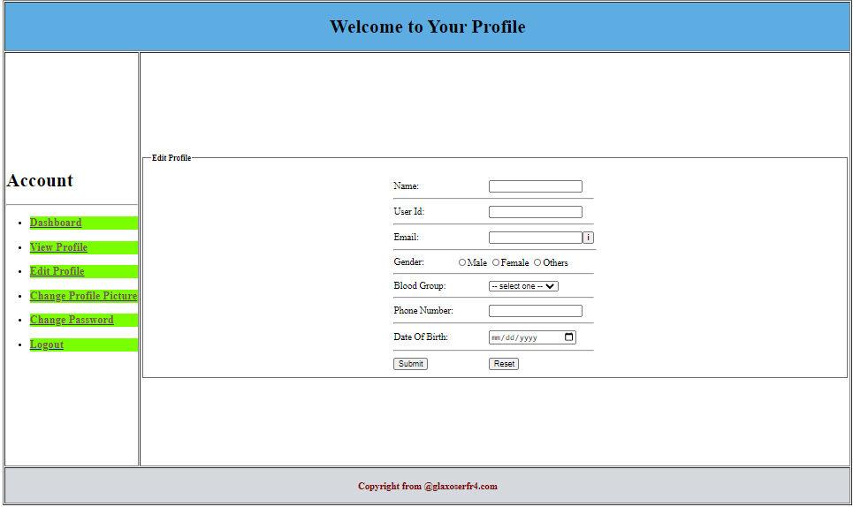

In this page the user can edit their profile as they want. Now he clicks on profile picture-

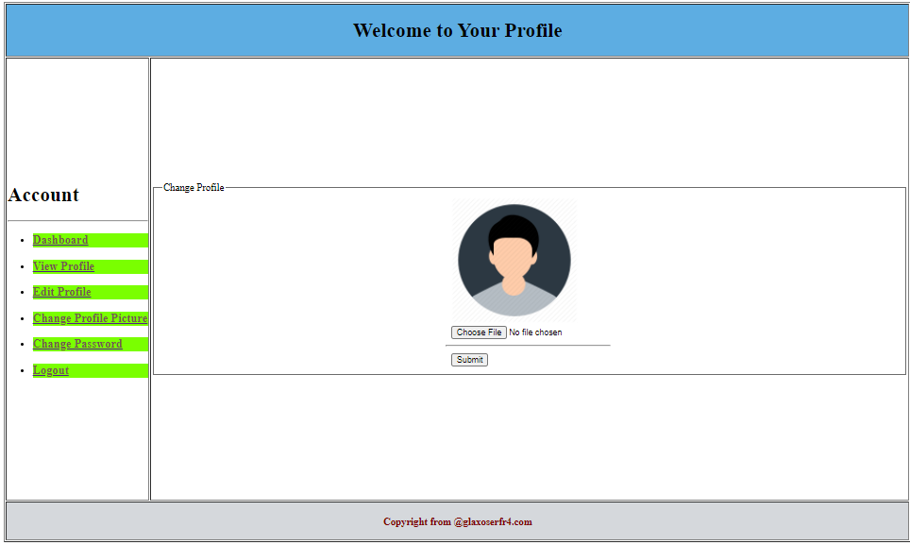

In this picture the user can change their profile picture.

Impact of this Project:

Describe the increasing importance of your project on modern society and environment.

How will people be benefitted from your project?

In this project we are tried our best to do better where it gives better performance for a user who is interested to use this News Portal System. Easily the user can maintain the portal systematically as this is as well performed website. The modern society can be benefited by this site from taking the services from this website. The people can easily find their regular around news, whole country news and world news as well.

Limitations and Possible Future Improvements:

In spite of doing this better performance it has some limitations and need to be improvements in future.

When we did the project sometimes the xampp does not working. It showed port error. Sometimes database connection failed and so on problem we faced. I think, this project keenly needs to show news headline slightly one by one in home page in future.

.

*[Note: Make sure that your report is maximum 10 pages (including cover page).*

|  |  |  |  |  |  |
| --- | --- | --- | --- | --- | --- |
| CO1.1 and CO2.1 Evaluation: Project Report Evaluation | | | | | |
| Project Proposal  (5) | Background  Study  (5) | Requirement Analysis  (5) | Entity  Diagram  (5) | System Images  against the  Specification (5) | Total (25) |
|  |  |  |  |  |  |
|  | | | | | |